Prelim 2 Problem 1 Fall 2020 MAE 4730/4730

Mean 19.81 Median 20 Standard Dev 3.82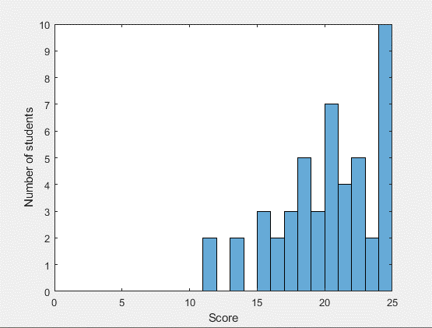

General Comments:
Lots of ways to do this problem, some with many parts, and correspondingly many ways to make mistakes. The rubric was pretty nice to students here – don’t get too comfortable! Notes:
- Review AMB – taking about G, taking about non-G useful points, and taking about everything else. Students who are unclear about AMB should review the HW problems that talk about different points – the little details there might be much more clear now. General rules:
  - G is always good, and easy. This is because r_G/C = 0 when C=G. No need to figure out a_G/F, though some students still did and included it. Don’t do that.
  - There are certain convenient points C that are not G. These convenient points are convenient because they are a fixed distance from G, like the hinge of a pendulum. However you still need to write a_G/F, the fixed frame, often not a_G/C (in case C is moving, like the cart here) even though you use r_G/C.
  - You can technically pick any point – you are just taking the cross product of some position vector with the LMB equations. It is just that for some points, we see that (r x ma) happens to be the time derivative of angular momentum. You technically do not need that to be true to get equations of motion, it’s just being picky about what “balancing angular momentum” should refer to.
  - Andy knows this stuff better than you know the back of your own hands. You should talk to him about it and be honest when you are confused. You should find a way to make it make sense for yourself personally the best you can. You can also ask the TA’s and stuff. For example, if I was confusing in the above, you should ask me about it. Fundamental understanding of concepts like these are some of the most important parts of the course.

- Many students forgot the normal force acting on the cart. This only mattered if you ended up needing the LMB on cart in the y-direction

- Many students could not get enough balance equations to complete the system

- There were definitely some misunderstandings about internal reaction forces, such as those you were supposed to find. They act equally but opposite on both the cart and the link(pendulum).

- The link is not a two-force member (the reaction force is not parallel to the link)! This would only be true if IG = 0. You can prove this to yourself by taking AMB/G.

- Maybe mistakes with the acceleration formulas. Half the time with forgetting that the point C has acceleration, and the other half dropping terms related to calculus

- A few students were successful doing LMB of the whole system, since there are no external forces in the x-direction. One of the cleanest way to do the problem (least work and # of EOMs) was: step 1, this LMB; step 2, AMB/C. That way you avoid all external forces beside gravity and obain 2 EOM immediately for the 2 unknowns xc and theta. You could then supplement these with 2 balance laws including the force components. On the other hand, since the goal was to find the forces, the posted solution are a little more straightforward, where one could alternatively exchange 1 of the 3 balance laws on the link for AMB/C.

