How-to Use Slack: Guide
Slack Workspace List
Current Slack workspace name & settings
Threads you are involved in (in channels or direct messages)
@ Mentions and Reactions and More
Channel List
Direct Messages
Search Bar
Main Channel Conversation
Your Personal Slack Settings
Other Slack Resources
Tips & Tricks

Overview of the ‘<name>.slack.com’ workspace
Here is what Slack looks like when you open it up in the desktop app. Below, find a brief description of how to use each of the sections of the workspace (as indicated by the different colored boxes).
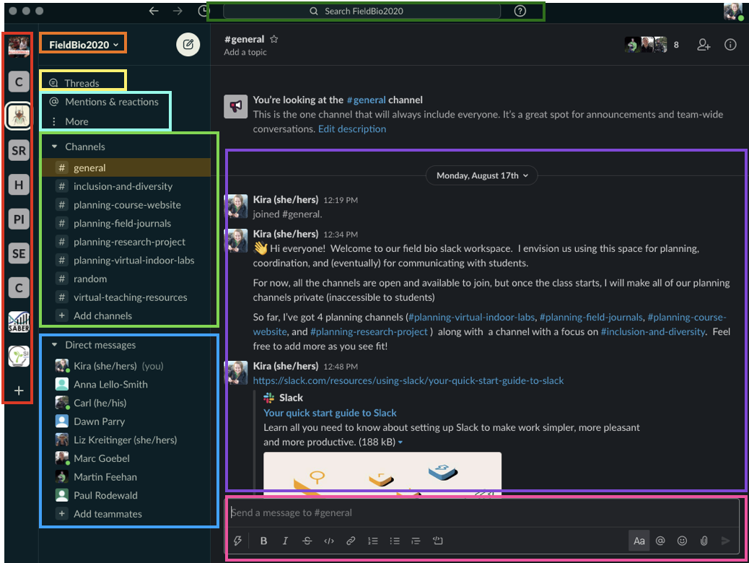

Slack Workspace List
- lists all of the Slack workspaces you belong to (you can view them all in one place)
- Click the “+” to add more (will prompt you to enter the Slack URL and log in)
Helpful links:
Getting Started: Join a Slack Workspace
Review your workspace’s settings

Current Slack workspace name & settings
- shows you the workspace url (fieldbio2020.slack.com)
-dropdown menu allows you to set workspace-specific preferences, invite new
members and customize
Helpful links:
What is a channel?

Threads you are involved in (in channels or direct messages)
- allow you to discuss topics in more detail
- keeps the main view of the conversation from getting cluttered
- if you wish to start a threaded conversation, respond to someone’s
comment by clicking on the speech bubble icon (‘reply in thread’)
- you can follow/unfollow threads by hovering over it, and clicking
the three vertical dots icon which will give you a dropdown menu
Helpful links:
Use Threads to Organize Discussions

@ Mentions and Reactions and More
- If you want to draw someone’s attention to a comment, you can
type “@“ followed by their name. They will be flagged Slack will
notify them here
- if someone adds a reaction to a comment you made (adding a
emoji to is), you will also be notified here
- the dropdown menu under “More” includes:
All Unread messages
All Direct messages
Saved items (click the flag icon to mark messages to save)
File Browser (review any files uploaded to the workspace)
People & User Groups (shows a list of workspace members)
Apps (browse available Slack add-ons)

Channel List
-a list of all of the channels to which you are currently subscribed
- every workspace member is subscribed to General
- add new channels by clicking the “+ Add channels” option
You can create a new channel or browse available channels
Current channels include (as of Aug 24, 2020):
# general: for all-purpose messaging about the class
# inclusion-and-diversity: for sharing ideas/discussing ways to improve DEI
with respect to the course, or field bio more broadly
# planning-course-website: for discussion/organizing/details regarding our course’s canvas page
# planning-field-journals: planning the field journal assignment and the
possible addition of 1 or 2 field journal-specific lab activities
# planning-research-project: for planning the research project
# planning-virtual-indoor-labs: for planning any of the other virtual labs
# random: anything that doesn’t fit into the other channels!
# virtual-teaching-resources: share tips/tricks/resources for virtual instruction

Direct Messages
- in this panel you can message or send files directly to any
workspace member, or group of workspace members.

Search Bar
- will query entire slack workspace for any search terms entered here

Main Channel Conversation
- contains the main conversation for the selected channel
- Slack will direct you to where you have last read, and help you stay
caught up

Messaging Window
- Compose and respond to messages here. You can add emojis, file attachments, or embed hyperlinks (and so much more!)
- You can either compose a new message to the slack channel, or you can respond to someone’s message in a threaded reply (which nests your response under their message). To do this, hover over the message and click on the speech bubble.

Your Personal Slack Settings
Setting Up Slack
Download the Slack Apps (computer/phone)
What is a workspace?
Setting up your profile

Your Profile & Preferences
Access Your Account
Manage Your Profile
Set Your Preferences
Adjust Your Notifications

Other Slack Resources
Using Slack
Work in Channels
Send Messages
Share Files and Conversations
Search

Navigating Slack

Tips & Tricks
Keep up with what’s important
Reduce noise in Slack (manage what gets your attention and what doesn’t)
Set up Slack for Work Hours

