Master Forest Owner Volunteer Program
- How to approach a visit and what to bring….

PRE-Assessment
Start with a phone conversation and listen to what the landowner is seeking to gain knowledge on or would like to do on the property; from that point try and tailor your visit to their needs.
- You may need to contact your regional director for a resource specific to a topic.

Identifying the Parcel and Possible Boundaries
Google Maps (Satellite or Terrain Layer)
County Tax Id Maps: Example Saratoga
- https://www.saratogacountyny.gov/county-initiatives/saratoga-county-assessment-
Web Soil Survey
- https://websoilsurvey.sc.egov.usda.gov/App/HomePage.htm

Tree Nurseries
Colonel William F. Fox Memorial Saratoga Tree Nursery
- https://www.dec.ny.gov/animals/9395.html
- Contact Local Soil and Water Conservation District

Deer Fencing Options and Seedling Protection
- https://smallfarms.cornell.edu/2018/01/low-cost-fence-designs-2/

Crop Tree Management
- https://cpb-us-e1.wpmucdn.com/blogs.cornell.edu/dist/d/5957/files/2015/03/Crop-tree-management-fact-sheet-2m6gbdf.pdf

Chain Saw Safety Course
- Game of Logging http://www.gameoflogging.com/
NYS DEC Resource e Guide for Creating and Maintaingn Viewing Areas
- https://www.dec.ny.gov/docs/remediation_hudson_pdf/hrviewshbk.pdf

Free Forest Management Guide to Increase Wildlife
- https://ny.audubon.org/sites/default/files/free_guide_forest_management_new_york_birds.pdf
- Other?

When Next Level Questions Come Up

Cooperating Forrester Program
- https://www.dec.ny.gov/docs/lands_forests_pdf/cooplist.pdf

DEC Stewardship Forester
- https://www.dec.ny.gov/lands/97398.html

Stumpage Report
https://www.dec.ny.gov/docs/lands_forests_pdf/sprsummer19.pdf
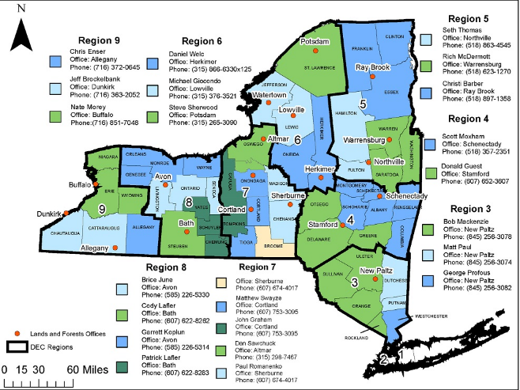

Additional Resources After the Visit
- NYFOA https://www.nyfoa.org/
- My Wood Lot https://www.mywoodlot.com/
- https://blogs.cornell.edu/cceforestconnect/
- Any major themes that come up contact your regional director for additional resources.

