Vegetation Management “Interfering Vegetation”

The Invasive Species Management Process

Define Invasive Species: 120 Billion Dollar Problem …..

Integrated Vegetation Management – controlling undesirable woody plants in the forest

What are interfering vegetative plants?

The word “treatment” is used here to describe the manner in which the vegetation is manipulated, often with the goal of killing the stems causing the interference. The treatment has two attributes – the method and the mode.
- Method is typically mechanical or chemical
- Mode is either broadcast or selective.

Integrated Pest Management (IPM) https://nysipm.cornell.edu/
- Adaptive approach exploring multiple options, targeting invasive species
- Selecting from a range of manual, mechanical, chemical, cultural and biological control methods
- The goal is to maximize effective control and to minimize negative environmental, economic and social impacts.

IPM means using a control method(s) that reflect the available
Land use goals Funding
Time Values of the community
Labor Require dedication over years

Invasive Species Management is an ongoing, iterative process. Five basic steps in management.
- Consider the phenology of the plant and best time for treatment.
www.dec.ny.gov/docs/lands_forests_pdf/tftismg17.pdf

Goals based on available Best Management Practices
- Eradication – eliminate all invasive plants and the seed bank from an area.
- Containment – prevent infestations of invasive species from spreading to uninfected areas.
- Suppression – reduce the size, abundance, and/or reproductive output of an invasive plant population below the threshold needed to maintain native species or ecosystem functions. Such functions include stream bank stabilization, flood mitigation, instream temperature control, uptake of nutrients in storm runoff, and wildlife habitat.

Prioritization
With a selected control strategy in hand prioritize the work effort.
Start with low density satellite populations then into the core of the infestation.

- Less difficult to more intensive, expensive and time consuming.
- Strategy helps to prevent minor, manageable infestations from becoming larger

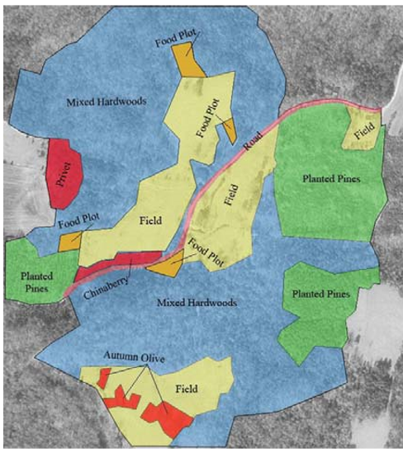
Managing Invasive Species with Land Use.

What does the woodlot owner have on their property? Be the eyes for the owner and point out what they don’t know.

Where?
What?
How many?
Time of year for flowering and seeding?

Work flow
Minimize travel and transport through areas and treat infested areas?

1. Case Study for Discussion: Trails and Mugwort

On a visit with a wood lot owner who has expressed an interest in putting horse and ATV trails throughout their 30-acre lot which is a retired apple orchard. The property is at the top of a hill and the majority of the property runs a gentle gradient down hill through the orchard where the trails are to be built. The owner has brought in fill for trail improvements and you notice the Mugwort (Artemesia vulgaris) an invasive perennial forb growing from the crushed rock pile to be used for trail building in wet areas of the property. What would you recommend?

http://nyis.info/invasive_species/mugwort-draft/

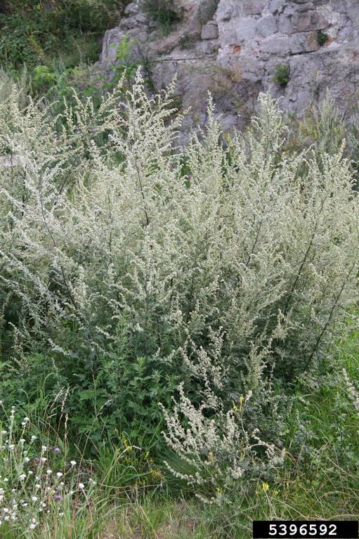

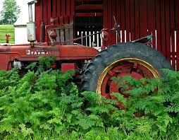

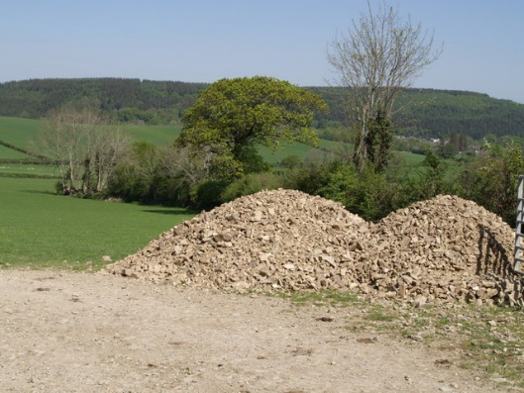

- Case Study HWA/Tree of Heaven

A woodlot owner takes you on stream side walk that is dominated by hemlock trees infested with Hemlock Woolly Adelgid. The trees are badly infested and in decline with poor crown ratios and canopy cover. Later in the walk which leads to the top of a ridge a stand of (Ailanthus altissima) Tree of Heaven is present. The invasive tree is a prolific seeder and a clonal species.

http://nyis.info/invasive_species/hemlock-woolly-adelgid/

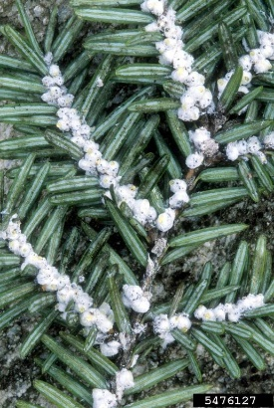
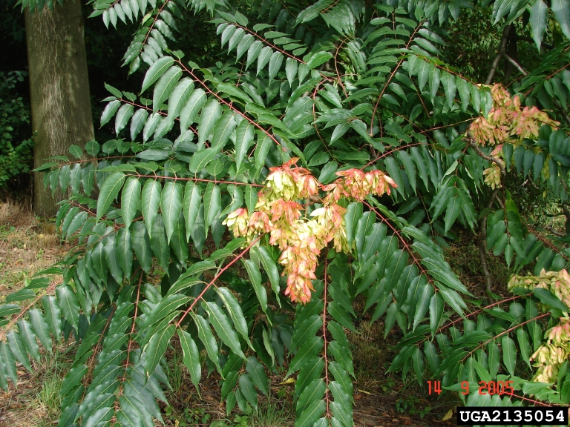

3. Case Study for Discussion:

The Smith Farm Parcel: Restoring a Pitch Pine Scrub Oak Forest for Karner Blue Butterfly Habitat

Directions
Read the short case scenario below describing a heavily logged parcel in northern Saratoga County. The property has been identified as a unique parcel that has the soil and plant characteristics similar to a Pine Barren and could be restored to support an endangered species.

For discussion: Consider the possible methods for managing vegetation on the property that could result in a successful habitat restoration similar to a pitch pine scrub oak barren for the production of Wild Lupine. Be prepared to discuss 1-3 strategies.

The 890-acre “Smith Farm” acquisition was purchased by OSI for $1.4 million from Finch Pruyn Timberlands. Located along the Hudson River, the property features more than two miles of river frontage. It is comprised of forest and wetland and is directly across the river from Hudson Pointe Preserve, which OSI also protected. The entire perimeter of the property is currently surrounded by an 8-foot-tall chain link fence. Prior to being sold the property was logged very aggressively. The parcel has since been evaluated to have site characteristics reminiscent of a Pitch Pine Scrub Oak Barren. The habitat has soil and plant species capable of supporting a flower called Wild Lupine which the federally endangered Karner Blue Butterfly relies on for food. There are trace species of plants and animals found on a typical Pine Barron. Note the list below. In the aerial photograph one can see the Eastern White Pine seed trees left behind from the harvest. In addition, there are several invasive species (interfering vegetation) found on the property. Note locations 1-3 on the map and the invasive species plant profile links for further understanding. There will be interpretive, equestrian, and bike trails installed before the property is open to the public as an add onto a nearby state park. Portions of the property will be restored to support habitat for the butterfly. What would your recommendations be for managing the property? Much of what is found here can be applied to smaller wood lots.

Some of the Interfering Vegetation found on the Parcel

Japanese Barberry https://www.invasive.org/alien/pubs/midatlantic/beth.htm
- Location (1) 9 acres of stems Dense population / Location (2) 8 acres monoculture of stems Impassable
- Harbor deer ticks and present a health hazard

Burning Bush https://www.nrcs.usda.gov/Internet/FSE_DOCUMENTS/stelprdb1081645.pdf
- In location 2b ½ acre

Black Locust Tree https://www.invasive.org/weedcd/pdfs/wgw/blacklocust.pdf
- Location 3 -(17 acres 84 stems 12 mature trees) Changes the soil composition

Honeysuckle Spp. http://nyis.info/invasive_species/honeysuckle/
- Locations along skid roads represented by green and purple dots.

3
2
1
https://imapinvasives.natureserve.org/imap/login.jsp

Karner Blue Butterfly
Karner blue butterflies live in areas described as oak savannas and pine barren ecosystems. These ecosystems are likely to contain many different herbaceous plants and grasses with scattered small groves of trees and shrubs. The open sunny nature of these systems creates the right conditions for wild lupine, a plant that the Karner blue caterpillar depends on. Wild lupine is the only plant that the caterpillar is known to feed on and therefore critical to survival of the butterfly. Adult Karner blues feed on nectar from a variety of wild flowers like the horsemint, butterflyweed, and bachelors button.

Pitch Pine-Scrub Oak Barrens
A globally rare natural community with only six documented occurrences statewide. Very few documented occurrences have good viability and very few are protected on public land or private conservation land. This community has a very restricted statewide distribution (correlated to pine barrens and sandy soils). Most examples are moderate in size and a few are good quality. Most pitch pine-scrub oak barrens are located within a suburban landscape and are threatened by development, invasive species, and fire suppression.
The number and acreage of pitch pine-scrub oak barrens in New York have probably declined slightly in recent decades due to fire suppression, disturbance by off-road vehicles, trash dumping, and development. The number and acreage of pitch pine-scrub oak barrens in New York have probably had very large declines from historical numbers due to fire suppression, fragmentation, disturbance by off-road vehicles, trash dumping, and development.
Plants and Animals in a Pine Barre
Fishers

White-tailed deer
Cottontail rabbits
Red and grey fox
Eastern coyotes
Eastern spadefoot toads
Eastern hognose snakes
Spotted turtles
Over 90 species of birds

Scrub oak
Pitch pine
Red oak
Black oak
Scarlet oak
Dwarf chestnut oak
Blueberry
Huckleberry
Sand cherry
Dune willow
Lupine

